**Web Development Report Csy1018 (Report)**

**Getting Started**

Before I started working on this website I visited other site and friends to get some feedback. I have collected huge information from different site and from my colleague before starting this job of making my website. And lastly I have modified almost all the information on my own and started working to make my website. This is the site that I had visited most to have most of the information.

<https://joel.sh/about>

**Designs**

**Sketches**

**Sketches Homepage**

I have designed my homepage according to the sketch below. Here I have added a picture of myself at the left side of the home page. I have added footer at the bottom and navigation bar across the whole on the top in each page. In the navigation bar there is link to github also. In this page just by the side of my picture there are some texts. The background color of this home page is light green. The color of header and footer is gray and the color of navigation bar is dark gray. In this way I want my home page in a simple and easy format so that the user can have almost all the idea of the website on only visiting the home page.

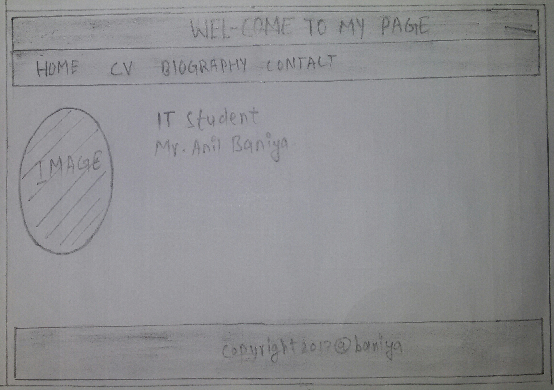

**Sketches CV**

At the top of my CV page there I have included the full form of CV at the centre. Just below that I have put the same navigation bar which is in the home page. In this page also on the left side there I have put the same image of myself. And just by the side of my image I have written my CV. The sketches design for this CV page is shown below:

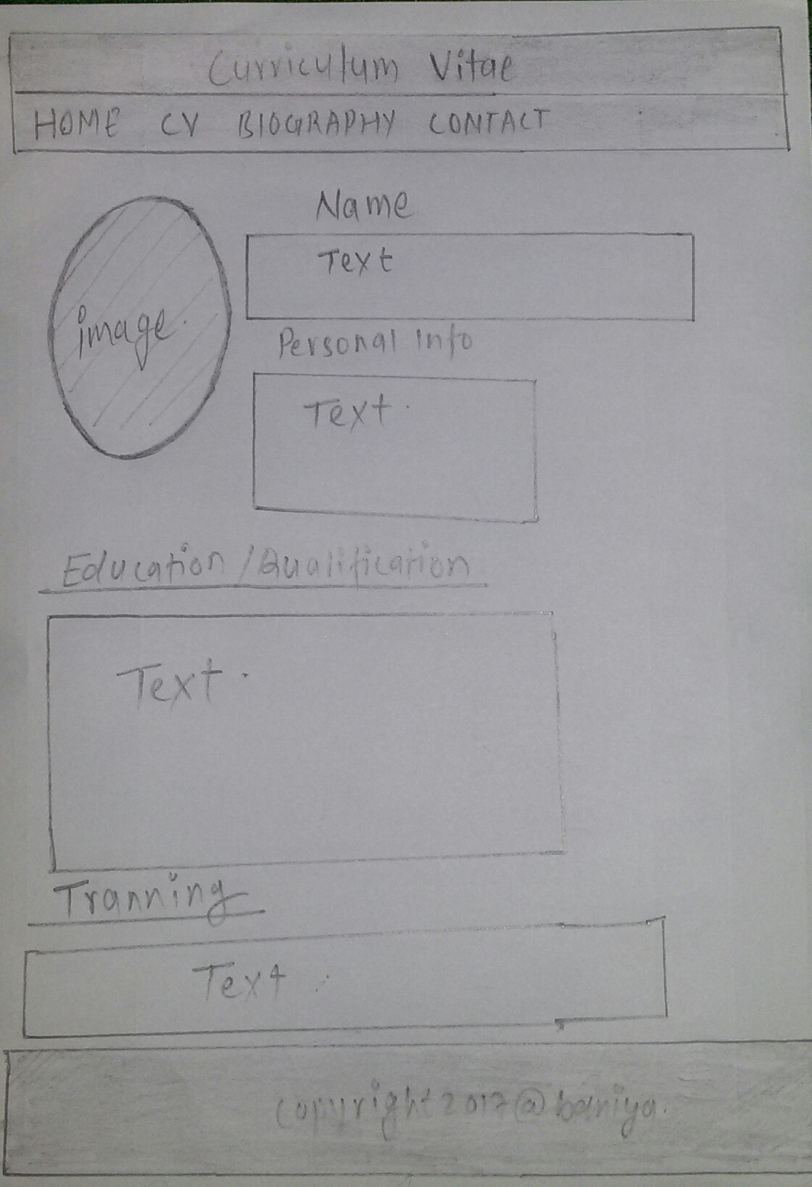

**Sketches Biography**

In this bio page also I have put the same navigation bar at the top of the page.

At the left side of this page I have added a different picture of myself. And by the side of this image I have written my short biography. The sketch design for this bio page is shown below:

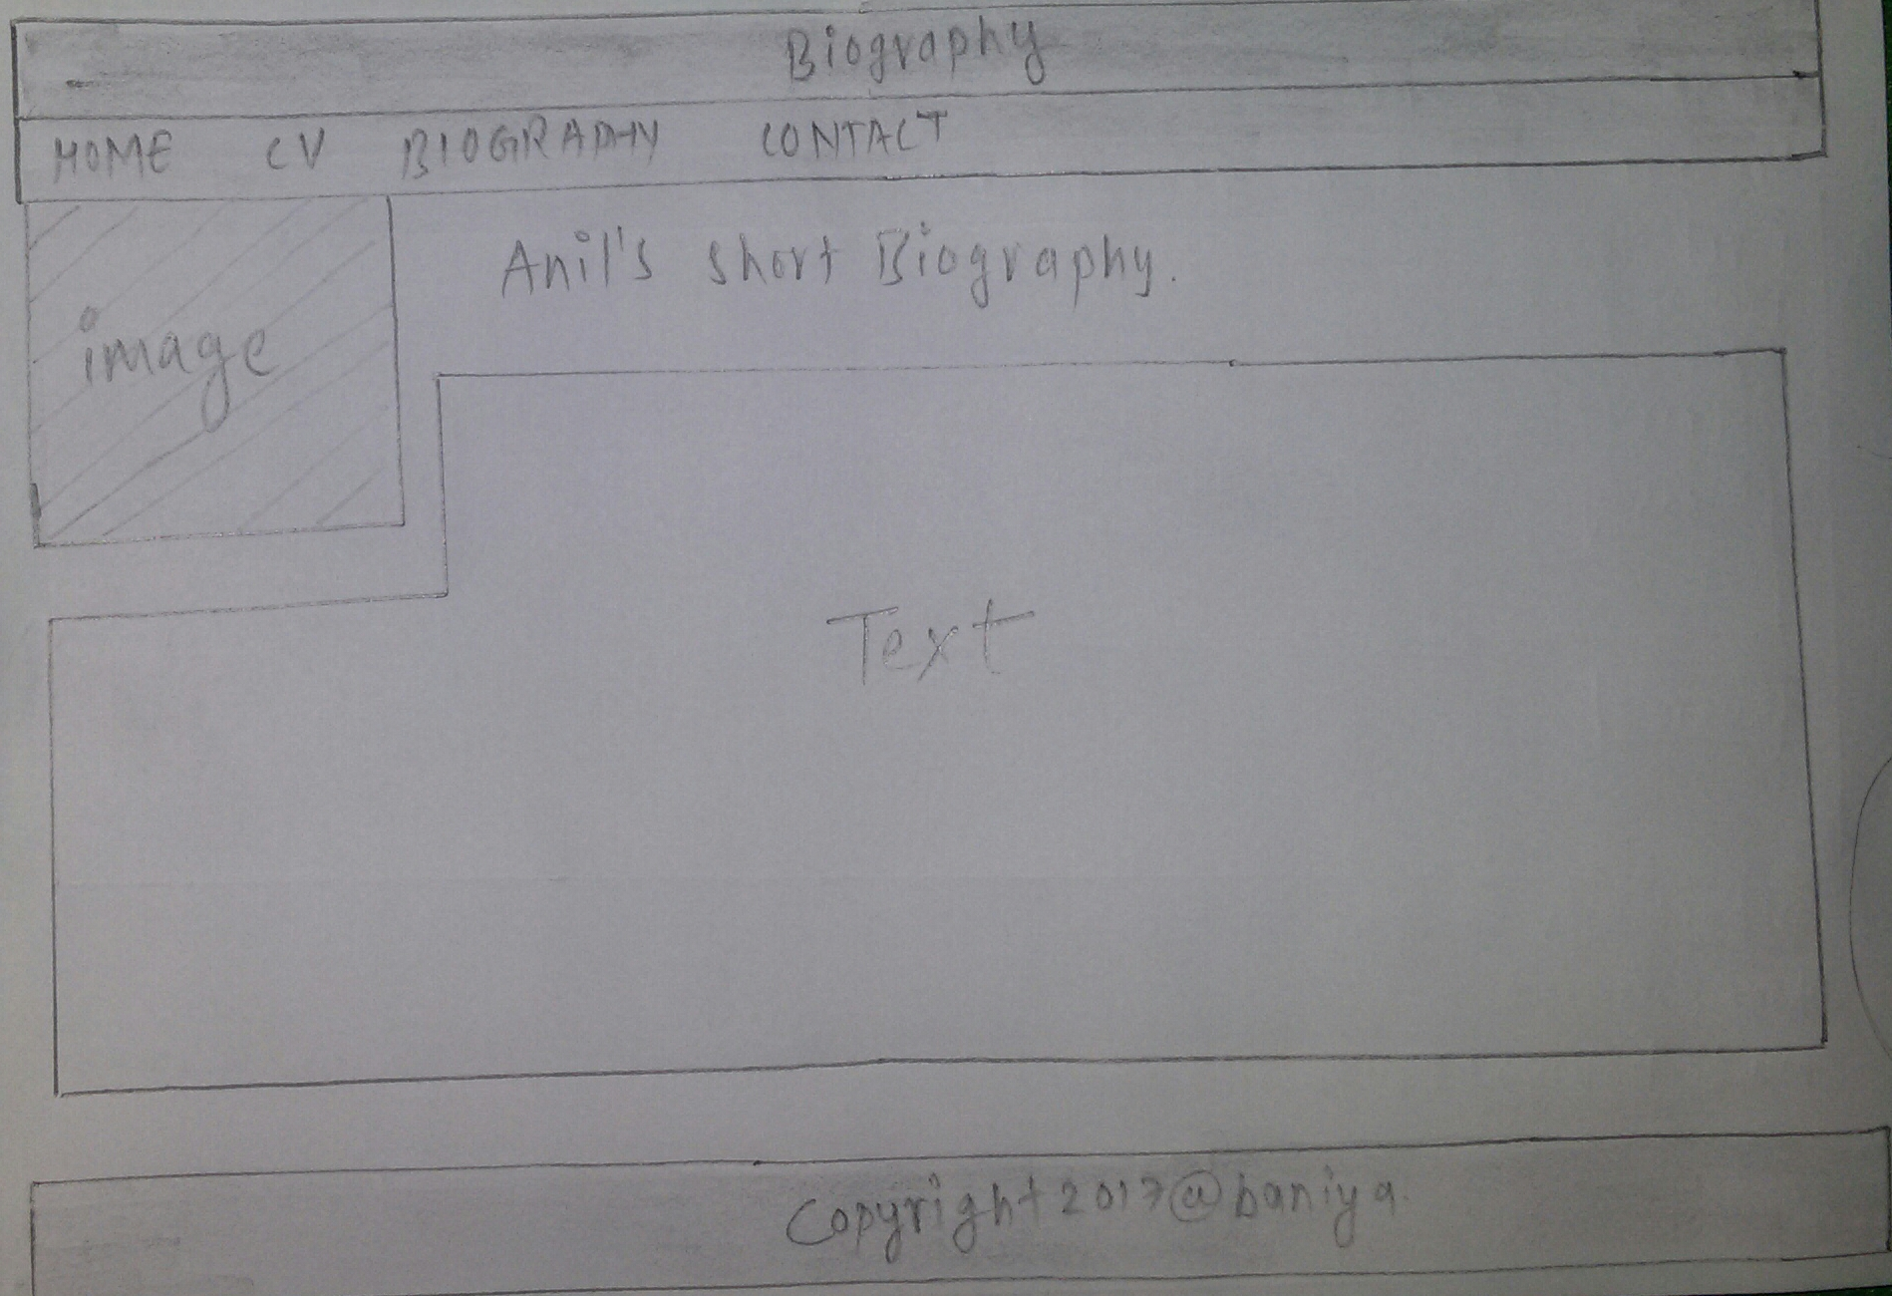

**Sketches Contact**

In this contact page also the navigation bar is as it is at the top of the page. I have not added any image on this page. Here the way that the user can contact me included. The background color of this contact text is light blue. The color in submit bottom is green. The sketch diagram for this contact page is shown below:

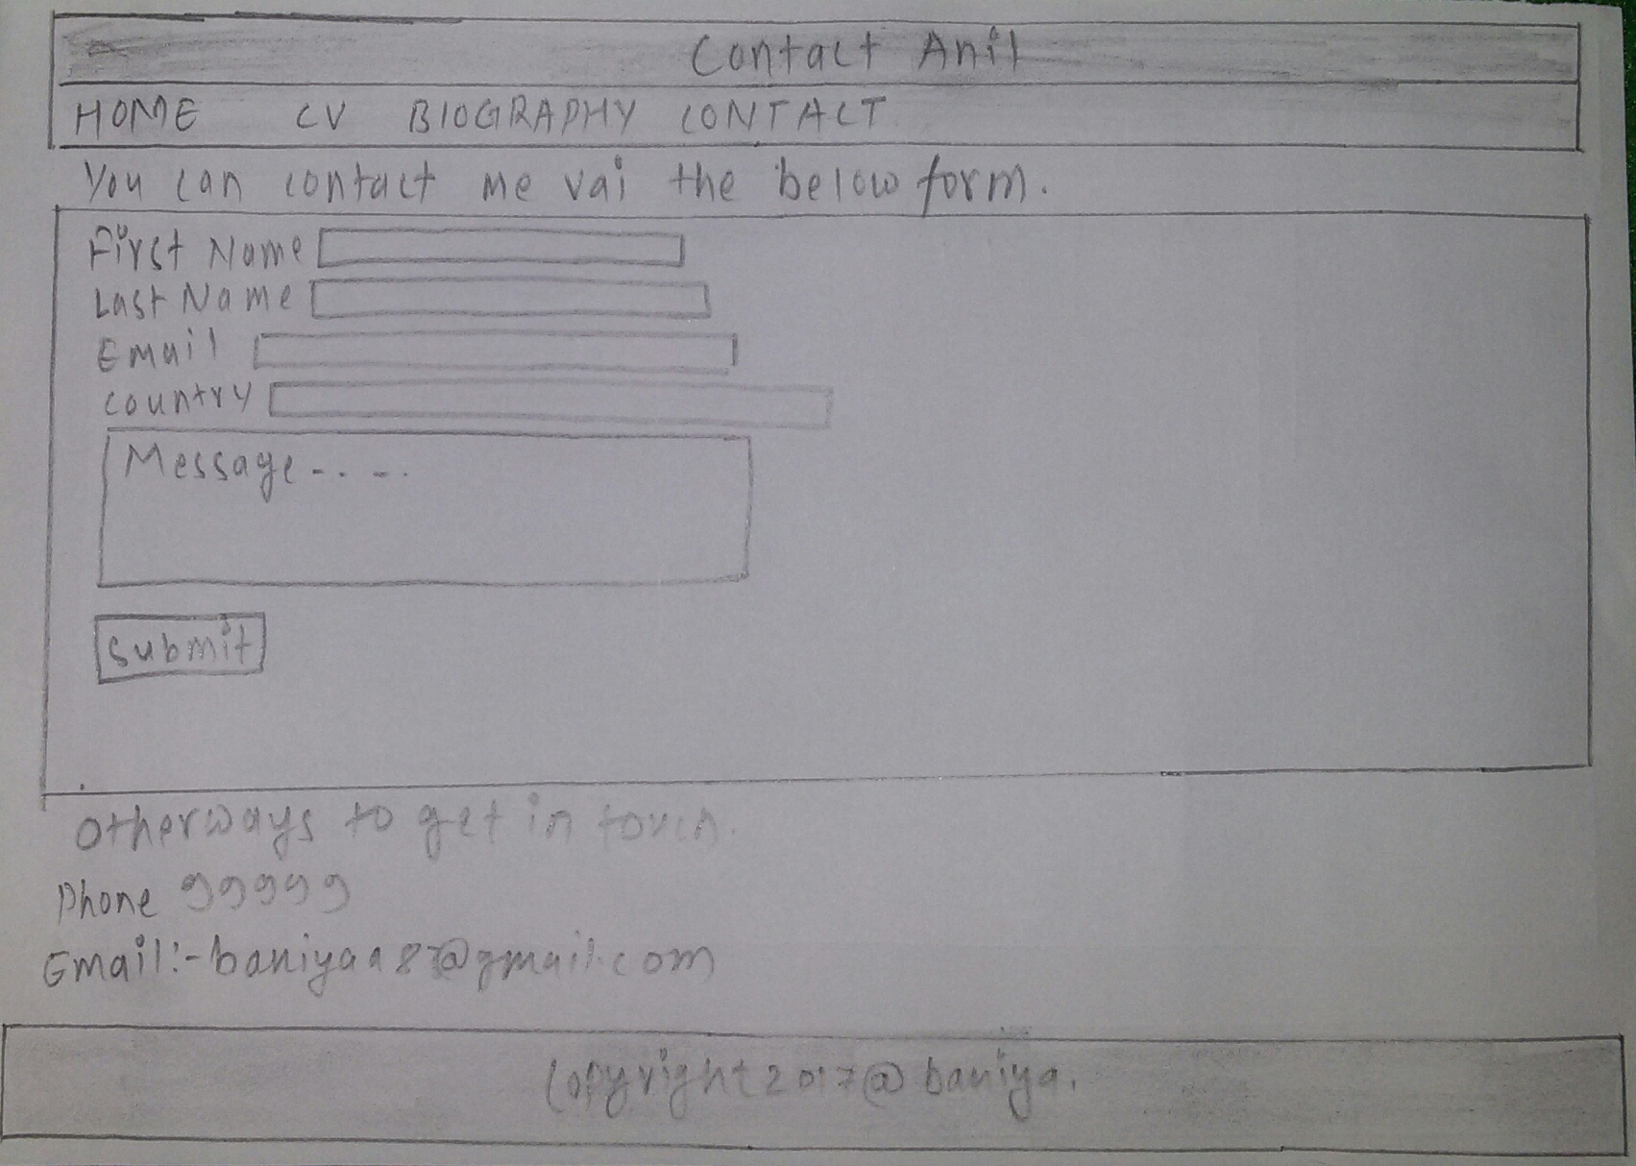

**Models of Good Practice**

While designing my entire website I have been looking through portfolio created by other people to try and find what was the most popular and good point in their websites. I have designed my website in a simplest way. I have not used any unappealing color and graphics, if I had used then that will divert the visitors away from my website.

Navigation system is also one of most important models of good practice which you have added on your website. In my website I have made the navigation system simple as much as I can. People can easily navigate around my website.

I have put the website which I have visited a lot from where I had taken many information and feedbacks to create my website.

**Conclusion**

In this way taking reference from other sites and from my colleague I start working in making this website. Here I have not included any crazy graphics and unappealing colors. Likewise I have created all the pages simple and easy as much as I can.